WaterMe

Show Humidity Diagram

Version 1.0

Revision History

|  |  |  |  |
| --- | --- | --- | --- |
| **Date** | **Version** | **Description** | **Author** |
| 31/Mai/2017 | 1.0 | First version | Paul Giesa |
| 13/Juni/2017 | 1.1 | Tests added | Olga Akymenko |
|  |  |  |  |
|  |  |  |  |

Table of Contents

1. Use-Case Name 4

1.1 Brief Description 4

1.2 Mockup 4

2. Flow of Events 5

2.1 Basic Flow 5

3. Espresso test 5

4. Preconditions 9

5. Postconditions 9

6. FP-Calculation 9

Show Humidity Diagram

# Use-Case Name

## Brief Description

The user is able to press a button to receive the current humidity level.

## Mockup

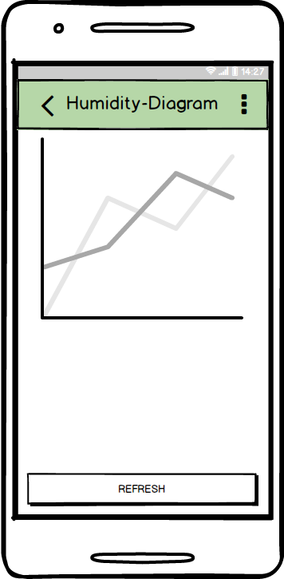

# Flow of Events

## Basic Flow

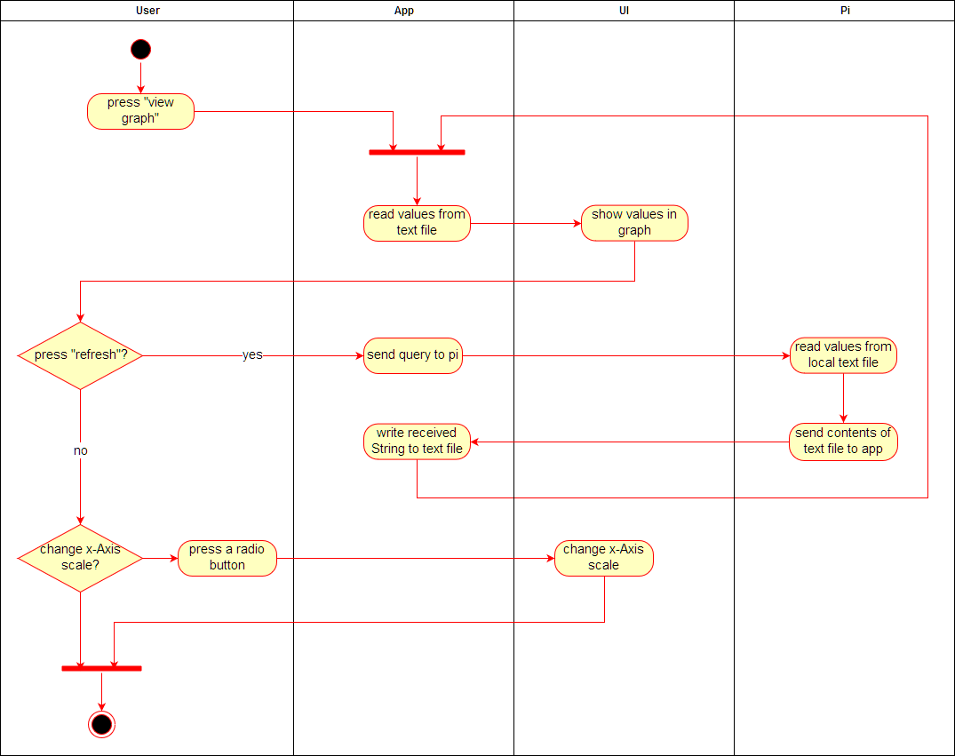

# Espresso test

**package** com.project.gta.demo;  
  
  
**import** android.support.test.espresso.ViewInteraction;  
**import** android.support.test.rule.ActivityTestRule;  
**import** android.support.test.runner.AndroidJUnit4;  
**import** android.test.suitebuilder.annotation.LargeTest;  
**import** android.view.View;  
**import** android.view.ViewGroup;  
**import** android.view.ViewParent;  
  
**import** org.hamcrest.Description;  
**import** org.hamcrest.Matcher;  
**import** org.hamcrest.TypeSafeMatcher;  
**import** org.junit.Rule;  
**import** org.junit.Test;  
**import** org.junit.runner.RunWith;  
  
**import static** android.support.test.InstrumentationRegistry.*getInstrumentation*;  
**import static** android.support.test.espresso.Espresso.*onView*;  
**import static** android.support.test.espresso.Espresso.*openActionBarOverflowOrOptionsMenu*;  
**import static** android.support.test.espresso.action.ViewActions.click;  
**import static** android.support.test.espresso.action.ViewActions.*closeSoftKeyboard*;  
**import static** android.support.test.espresso.action.ViewActions.*replaceText*;  
**import static** android.support.test.espresso.matcher.ViewMatchers.*isDisplayed*;  
**import static** android.support.test.espresso.matcher.ViewMatchers.*withClassName*;  
**import static** android.support.test.espresso.matcher.ViewMatchers.withContentDescription;  
**import static** android.support.test.espresso.matcher.ViewMatchers.withId;  
**import static** android.support.test.espresso.matcher.ViewMatchers.*withParent*;  
**import static** android.support.test.espresso.matcher.ViewMatchers.withText;  
**import static** org.hamcrest.Matchers.allOf;  
**import static** org.hamcrest.Matchers.is;  
  
@LargeTest  
@RunWith(AndroidJUnit4.**class**)  
**public class** UCShowHumidityDiagram {  
  
 @Rule  
 **public** ActivityTestRule<MainMenu> **mActivityTestRule** = **new** ActivityTestRule<>(MainMenu.**class**);  
  
 @Test  
 **public void** uCShowHumidityDiagram() {  
 ViewInteraction appCompatButton = *onView*(  
 *allOf*(*withId*(R.id.***BTNmyplants***), *withText*(**"My plants"**),  
 *withParent*(*allOf*(*withId*(R.id.***mainmenu***),  
 *withParent*(*withId*(R.id.***activity_main_menu***)))),  
 *isDisplayed*()));  
 appCompatButton.perform(*click*());  
  
 ViewInteraction actionMenuItemView = *onView*(  
 *allOf*(*withId*(R.id.***changescale***), *withContentDescription*(**"Change scale"**), *isDisplayed*()));  
 actionMenuItemView.perform(*click*());  
  
 ViewInteraction editText = *onView*(  
 *allOf*(*withClassName*(*is*(**"android.widget.EditText"**)),  
 *withParent*(*allOf*(*withId*(R.id.***custom***),  
 *withParent*(*withId*(R.id.***customPanel***)))),  
 *isDisplayed*()));  
 editText.perform(*click*());  
  
 ViewInteraction editText2 = *onView*(  
 *allOf*(*withClassName*(*is*(**"android.widget.EditText"**)),  
 *withParent*(*allOf*(*withId*(R.id.***custom***),  
 *withParent*(*withId*(R.id.***customPanel***)))),  
 *isDisplayed*()));  
 editText2.perform(*replaceText*(**"test"**), *closeSoftKeyboard*());  
  
 ViewInteraction appCompatButton2 = *onView*(  
 *allOf*(*withId*(android.R.id.***button1***), *withText*(**"OK"**),  
 *withParent*(*allOf*(*withId*(R.id.***buttonPanel***),  
 *withParent*(*withId*(R.id.***parentPanel***)))),  
 *isDisplayed*()));  
 appCompatButton2.perform(*click*());  
  
 ViewInteraction appCompatImageView = *onView*(  
 *allOf*(*withId*(R.id.***image1***),  
 *withParent*(*allOf*(*withId*(R.id.***LayoutPlants1***),  
 *withParent*(*withId*(R.id.***activity_single_plant_menu***)))),  
 *isDisplayed*()));  
 appCompatImageView.perform(*click*());  
  
 ViewInteraction appCompatButton3 = *onView*(  
 *allOf*(*withId*(R.id.***BTNgraph***), *withText*(**"View Graph"**), *isDisplayed*()));  
 appCompatButton3.perform(*click*());  
  
 ViewInteraction appCompatButton4 = *onView*(  
 *allOf*(*withId*(R.id.***BTNrefresh***), *withText*(**"Refresh"**),  
 *withParent*(*allOf*(*withId*(R.id.***activity_humidity_diagram***),  
 *withParent*(*withId*(android.R.id.***content***)))),  
 *isDisplayed*()));  
 appCompatButton4.perform(*click*());  
  
 *openActionBarOverflowOrOptionsMenu*(*getInstrumentation*().getTargetContext());  
  
 ViewInteraction appCompatTextView = *onView*(  
 *allOf*(*withId*(R.id.***title***), *withText*(**"Change scale"**), *isDisplayed*()));  
 appCompatTextView.perform(*click*());  
  
 ViewInteraction appCompatCheckedTextView = *onView*(  
 *allOf*(*withId*(android.R.id.***text1***), *withText*(**"24h"**),  
 *childAtPosition*(  
 *allOf*(*withId*(R.id.***select_dialog_listview***),  
 *withParent*(*withId*(R.id.***contentPanel***))),  
 0),  
 *isDisplayed*()));  
 appCompatCheckedTextView.perform(*click*());  
  
 *openActionBarOverflowOrOptionsMenu*(*getInstrumentation*().getTargetContext());  
  
 ViewInteraction appCompatTextView2 = *onView*(  
 *allOf*(*withId*(R.id.***title***), *withText*(**"Change scale"**), *isDisplayed*()));  
 appCompatTextView2.perform(*click*());  
  
 ViewInteraction appCompatCheckedTextView2 = *onView*(  
 *allOf*(*withId*(android.R.id.***text1***), *withText*(**"three days"**),  
 *childAtPosition*(  
 *allOf*(*withId*(R.id.***select_dialog_listview***),  
 *withParent*(*withId*(R.id.***contentPanel***))),  
 1),  
 *isDisplayed*()));  
 appCompatCheckedTextView2.perform(*click*());  
  
 *openActionBarOverflowOrOptionsMenu*(*getInstrumentation*().getTargetContext());  
  
 ViewInteraction appCompatTextView3 = *onView*(  
 *allOf*(*withId*(R.id.***title***), *withText*(**"Change scale"**), *isDisplayed*()));  
 appCompatTextView3.perform(*click*());  
  
 ViewInteraction appCompatCheckedTextView3 = *onView*(  
 *allOf*(*withId*(android.R.id.***text1***), *withText*(**"one week"**),  
 *childAtPosition*(  
 *allOf*(*withId*(R.id.***select_dialog_listview***),  
 *withParent*(*withId*(R.id.***contentPanel***))),  
 2),  
 *isDisplayed*()));  
 appCompatCheckedTextView3.perform(*click*());  
  
 *openActionBarOverflowOrOptionsMenu*(*getInstrumentation*().getTargetContext());  
  
 ViewInteraction appCompatTextView4 = *onView*(  
 *allOf*(*withId*(R.id.***title***), *withText*(**"Change scale"**), *isDisplayed*()));  
 appCompatTextView4.perform(*click*());  
  
 ViewInteraction appCompatCheckedTextView4 = *onView*(  
 *allOf*(*withId*(android.R.id.***text1***), *withText*(**"optimal"**),  
 *childAtPosition*(  
 *allOf*(*withId*(R.id.***select_dialog_listview***),  
 *withParent*(*withId*(R.id.***contentPanel***))),  
 3),  
 *isDisplayed*()));  
 appCompatCheckedTextView4.perform(*click*());  
  
 }  
  
 **private static** Matcher<View> childAtPosition(  
 **final** Matcher<View> parentMatcher, **final int** position) {  
  
 **return new** TypeSafeMatcher<View>() {  
 @Override  
 **public void** describeTo(Description description) {  
 description.appendText(**"Child at position "** + position + **" in parent "**);  
 parentMatcher.describeTo(description);  
 }  
  
 @Override  
 **public boolean** matchesSafely(View view) {  
 ViewParent parent = view.getParent();  
 **return** parent **instanceof** ViewGroup && parentMatcher.matches(parent)  
 && view.equals(((ViewGroup) parent).getChildAt(position));  
 }  
 };  
 }  
}

# Preconditions

The app needs an active connection to the Pi. Also the user has to enter the “Single Plant Menu”.

# Postconditions

The graph will show the course of the humidity.

# FP-Calculation

